Setup Instructions
For HDMI
- Plug one end of the HDMI cable into the "HDMI Out" port on the back of your cable or satellite box and plug the other end of the cable into one of the "HDMI/DVI In" ports on the back of your LG TV.
Helpful Hints
HDMI cable  Delivers the picture and sound to your LG TV | 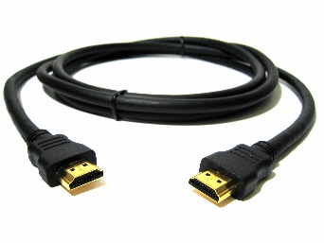
HDMI port | 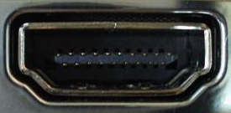
Side connection panel on your LG TV

- Turn on the TV.
Helpful Hints
Power button to turn on your LG TV on the TV
Power button to turn on your LG TV on the remote control

- Press the "Input" button until the HDMI port you used appears on the TV.
Helpful Hints
Input button on your LG TV
Input button on your remote control
HDMI Port Numbers

- Enjoy your LG TV.

